Walkthrough 10 Application Descriptor

https://sapui5.hana.ondemand.com/#/topic/8f93bf2b2b13402e9f035128ce8b495f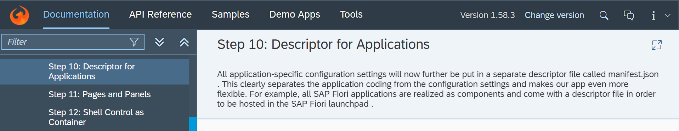

Core Codes:

Component.js

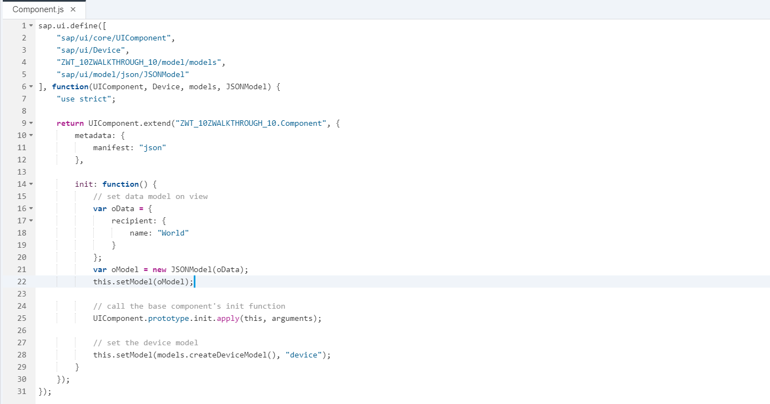

manifest.json

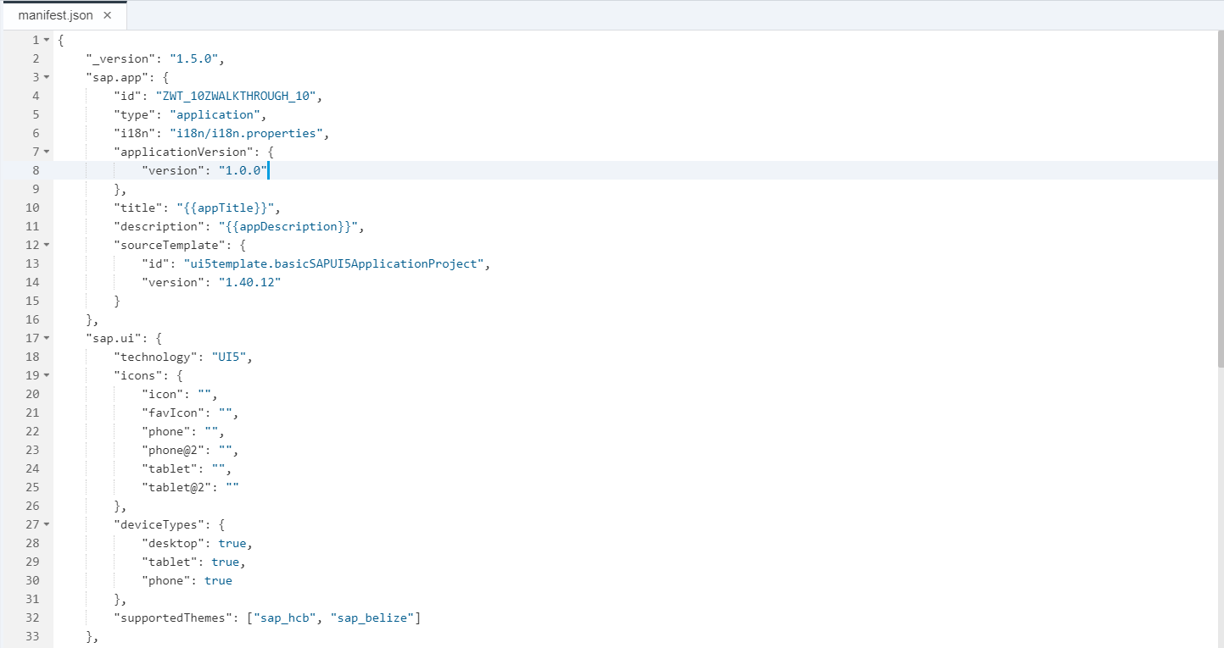

Controller.

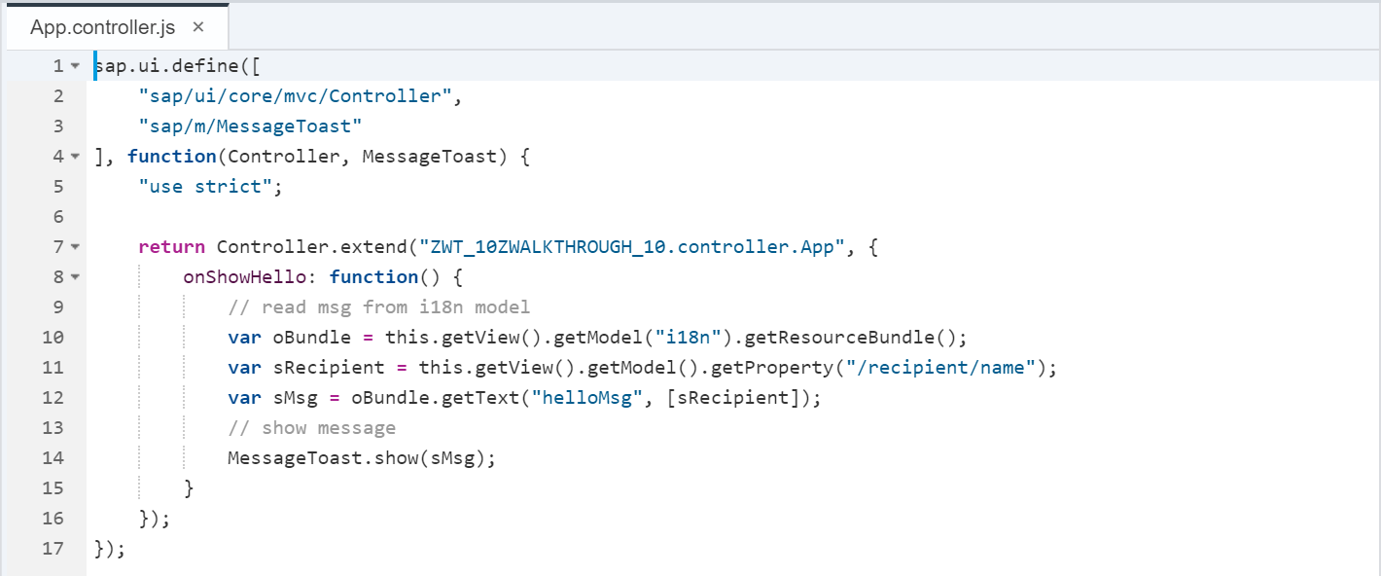

View.

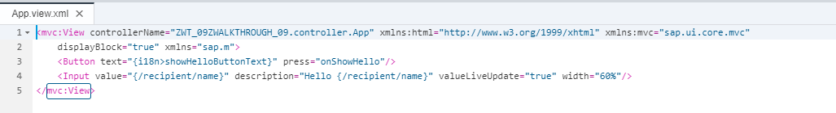

I18n

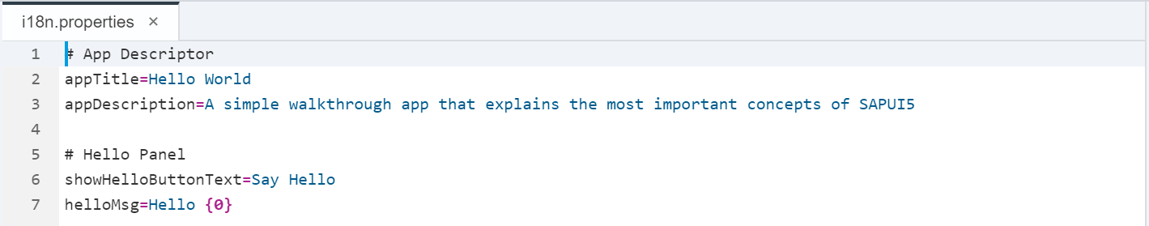

Result:

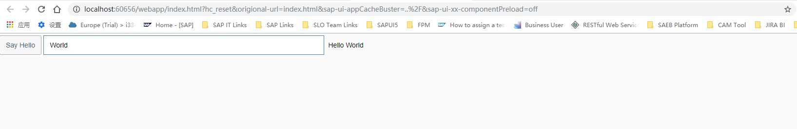

Git:

WALKTHROUGH_10

2018/11/02 XiaoMi Beijing Zac,Xie